True Positive

* Here the first word ‘True’ means that the prediction was True or False
* And the second word means the class, i.e., the positive class (positive class also means the class which is the preferred output). For example, in a scenario where model needs to predict whether the give image is dog or no, ‘is dog’ is the positive class and ‘no dog’ is negative class
* So, True positive means that the expected class was predicted correctly

False Positive

* False Positive means that the positive class(‘is dog’) is falsely/wrongly predicted.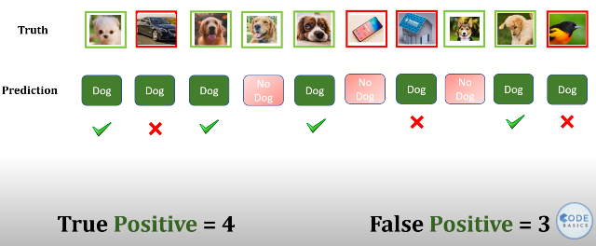

True Negative

* This means that the Negative class(‘no dog’) was correctly predicted

False Negative

* This means that the Negative class(‘no dog’) was wrongly/falsely predicted i.e., the model predicted the image to be ‘is dog’ but in reality the image was not of a dog

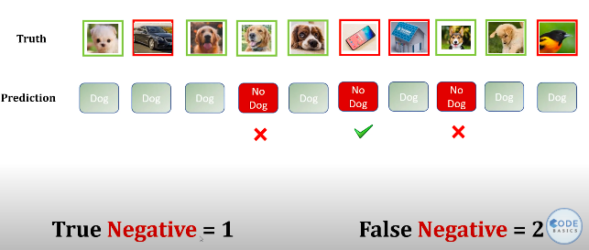

Precision

* Precision is out of all ***dog predictions*** how many you got it right
* Therefore, precision for Truth is 4 / 7 = 0.57
* Precision for False is 1 / 3 = 0.33
* Precision = TP / (TP + FP)
* 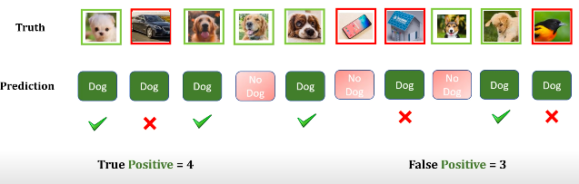

Recall

* Recall is out of all ***dog truth*** how many you got it right?
* Recall for Truth = 4 / 6 = 0.67
* Recall for False = 1 / 4 = 0.25
* Recall = TP / (TP+FN)
* 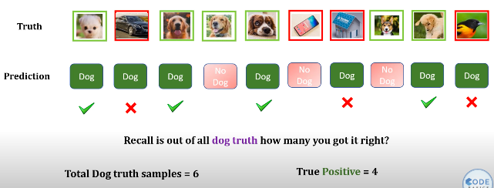

***NOTE*** :

* For precision, think about predictions as your base
* For recall, think about truth as you base

F! Score

* 

Accuracy

* How many predictions without any conditions we got it right
* Therefore, Accuracy = 5 / 10